Practical No.2
Write a Program to implement web Service to Calculate factorial of a given number. Deploy the above Web service properly and call it by designing appropriate interface in JAVA / .NET.

Server Side

package Server;

import javax.jws.WebService;
import javax.jws.WebMethod;
import javax.jws.WebParam;

@WebService(serviceName = "FactorialWS")
public class FactorialWS {

@WebMethod(operationName = "factorial")
public int factorial(@WebParam(name = "num") int num) {
//TODO write your implementation code here:
int f = 1;
for(int i=1;i<=num;i++)
{
f = f * i;
}
return f;
}
}
Server-Side Output:-
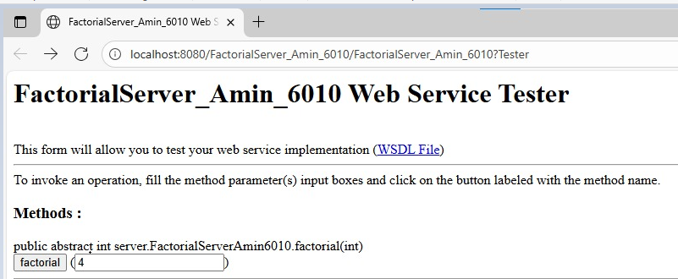
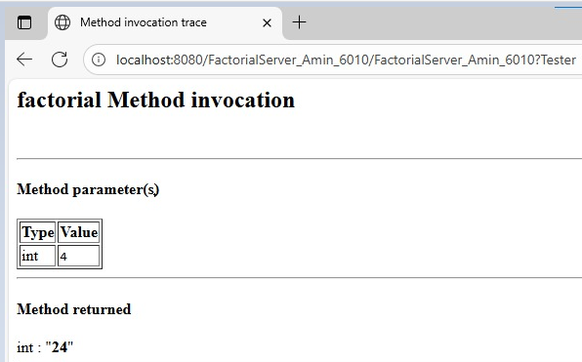

Client-Side Code:-
Input.jsp:-

<%@page contentType="text/html" pageEncoding="UTF-8"%>
<!DOCTYPE html>
<html>
<body>
<h1>Shahid Ansari 123</h1>
<form action="output.jsp" method="POST">
Enter The Number : <input type="text" name="t1" value="" />
<br><br>
<input type="submit" value="Factorial" />
</form>
</body>
</html>
Output.jsp:-
<%@page contentType="text/html" pageEncoding="UTF-8"%>
<html>
<body>
<h1>Shahid Ansari 123</h1>
<%-- start web service invocation --%><hr/>
<%
try {
Client.FactorialWS_Service service = new Client.FactorialWS_Service();
Client.FactorialWS port = service.getFactorialWSPort();
// TODO initialize WS operation arguments here
int num = Integer.parseInt(request.getParameter("t1"));
// TODO process result here
int result = port.factorial(num);
out.println("Factorial = "+result);
} catch (Exception ex) {
// TODO handle custom exceptions here
}
%>
<%-- end web service invocation --%><hr/>
</body>
</html>

Client-Side Output:-
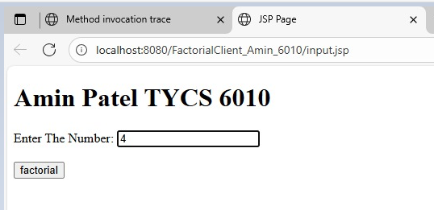

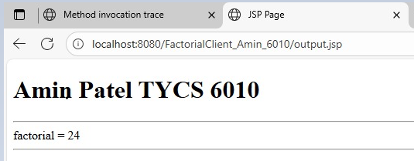
Web Service Client (.NET Client)
Note: before executing the code make sure that the web service is deployed.
Copy WSDL path from java execution and paste here
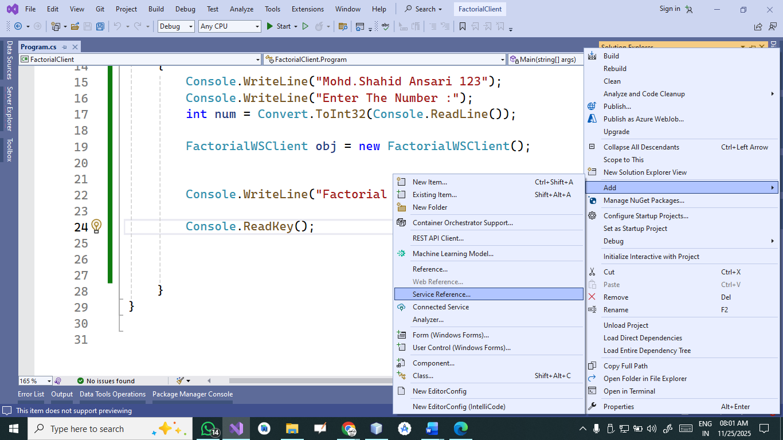

using System;
using System.Collections.Generic;
using System.Linq;
using System.Text;
using System.Threading.Tasks;

using FactorialClient.ServiceReference1;

namespace FactorialClient
{
internal class Program
{
static void Main(string[] args)
{
Console.WriteLine("Mohd.Shahid Ansari 123");
Console.WriteLine("Enter The Number :");
int num = Convert.ToInt32(Console.ReadLine());

FactorialWSClient obj = new FactorialWSClient();

Console.WriteLine("Factorial =" + obj.factorial(num));

Console.ReadKey();
}
}
}

Output:-
